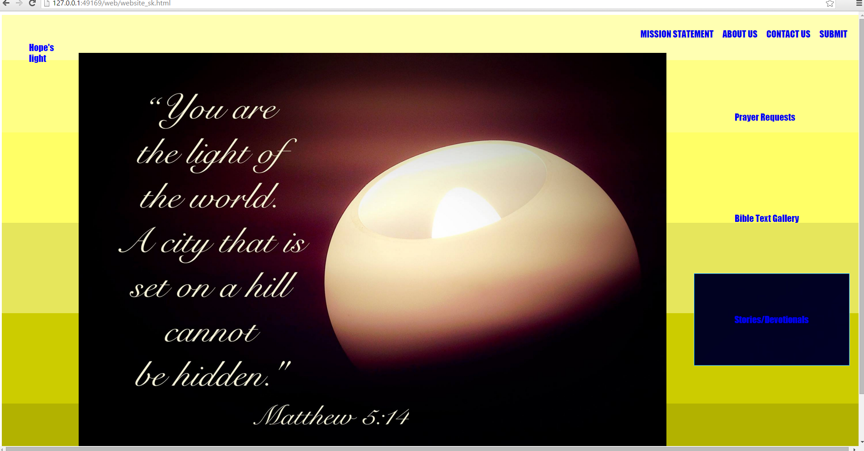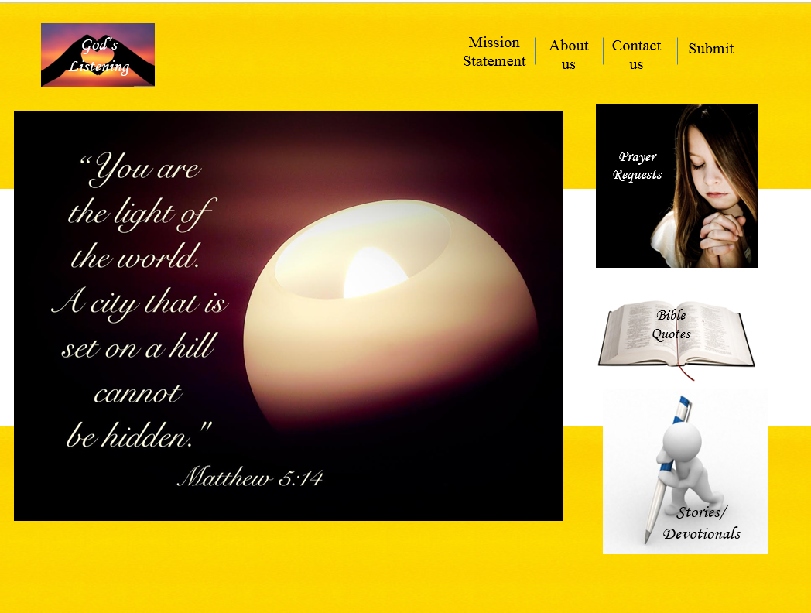

On a scale of 1 to 10, how close are you to accomplishing your design?

I think I’m on a 6/10. I have the navigation right. The hyperlink is all done.

4. If you evaluate less than a 10, what is standing in your way to make it a 10?

The web needs a logo. The fonts needs to be changed. The background needs work and there are no pictures on the right with the prayer requests, Bible text Gallery, stories/devotionals. Also the top is looking neat and ordered, but what I have looks to wide.

5. What are the problems you are running into?

I think the first problem would be time. It takes me a long time to the simplest things on code, because I try a lot of things and see how it turns out. If I don’t know how to do it I google it. I don’t think this is bad, because I have learned a lot and am enjoying it, but I need to give more time then what I think it will take.

Another problem is some things I really don’t know how to do: like making a slideshow with the pictures for my home page

6. What questions do you have?

How making a slideshow with the pictures for my home page works?

7. What can you do to solve those problems?

Google it, ask Mr. Strack, try it yourself

8. Specifically, what knowledge do you need to find in order to solve your problems and answer your questions?

More CSS knowledge and Html. Pictures

Code evaluation:

1. Is your code indented and organized?

I think it pretty neat and indented.

2. Are there any errors on your page?

No errors. No pink colors

3. Do all elements open and close in the right places?

Yup.

4. Is the proper syntax used?

I think so I used basically what we used before, but different id. etc.